**2018 PEW RESEARCH CENTER’S AMERICAN TRENDS PANEL**

**WAVE 33 March 2018**

**March 27 – April 9, 2018[1]**

BASE: ASK ALL

*Scripter: Randomize and record order of items a-f.*

*Scripter: Split across 2 screens*

**FUTURE [S]**

Do you think each of the following things will or will not happen in the next 50 years, that is, before the year 2068?

1. People will routinely travel in space as tourists
2. Will definitely happen
3. Will probably happen
4. Will probably not happen
5. Will definitely not happen
6. People will build colonies that can be lived in for long periods of time on other planets
7. Will definitely happen
8. Will probably happen
9. Will probably not happen
10. Will definitely not happen
11. Most of the meat people eat will be grown in a lab
12. Will definitely happen
13. Will probably happen
14. Will probably not happen
15. Will definitely not happen
16. The average person in the U.S. will live to be at least 120 years old
17. Will definitely happen
18. Will probably happen
19. Will probably not happen
20. Will definitely not happen
21. We will eliminate almost all birth defects by manipulating the genes of an embryo before a baby is born
22. Will definitely happen
23. Will probably happen
24. Will probably not happen
25. Will definitely not happen
26. We will routinely use implanted sensors to monitor and adjust all food and medications that enter our bloodstream
27. Will definitely happen
28. Will probably happen
29. Will probably not happen
30. Will definitely not happen

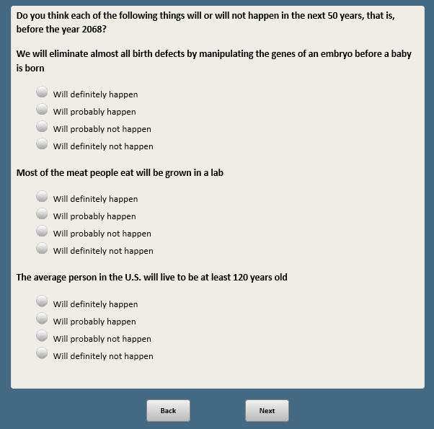 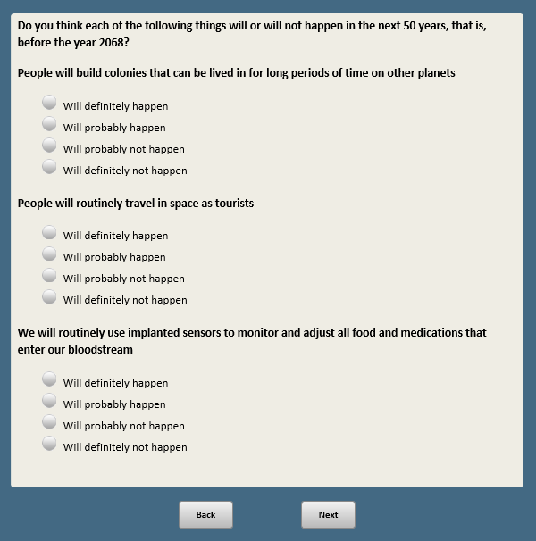

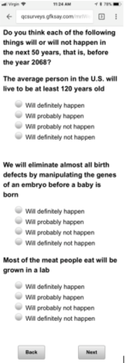 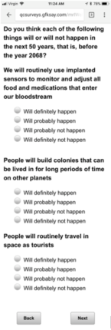

Base: ASK ALL

**SPACE1 [S]**

In the past 12 months, how much, if anything, have you heard or read about NASA, the National Aeronautics and Space Administration?

1. A lot
2. A little
3. Nothing at all

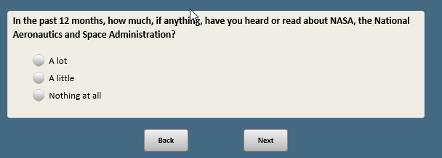

*Note: No SPACE2*

Base: ASK ALL

*Scripter: Randomize and record order of items a-i.*

*Scripter: Split across 2 screens.*

**SPACE3 [S]**

How would you rate each of the following priorities for NASA’s space efforts?

1. Searching for life and planets that could support life
2. Should be a top priority
3. Should be an important but lower priority
4. Should not be too important
5. Should not be done
6. Searching for raw materials and natural resources that could be used on Earth
7. Should be a top priority
8. Should be an important but lower priority
9. Should not be too important
10. Should not be done
11. Conducting basic scientific research to increase knowledge and understanding of space
12. Should be a top priority
13. Should be an important but lower priority
14. Should not be too important
15. Should not be done
16. Developing technologies that could be adapted for uses other than space exploration
17. Should be a top priority
18. Should be an important but lower priority
19. Should not be too important
20. Should not be done
21. Monitoring asteroids and other objects that could potentially hit the Earth
22. Should be a top priority
23. Should be an important but lower priority
24. Should not be too important
25. Should not be done
26. Monitoring key parts of the Earth’s climate system
27. Should be a top priority
28. Should be an important but lower priority
29. Should not be too important
30. Should not be done
31. Sending human astronauts to explore the moon
32. Should be a top priority
33. Should be an important but lower priority
34. Should not be too important
35. Should not be done
36. Sending human astronauts to explore Mars
37. Should be a top priority
38. Should be an important but lower priority
39. Should not be too important
40. Should not be done
41. Conducting scientific research on how space travel affects human health
42. Should be a top priority
43. Should be an important but lower priority
44. Should not be too important
45. Should not be done

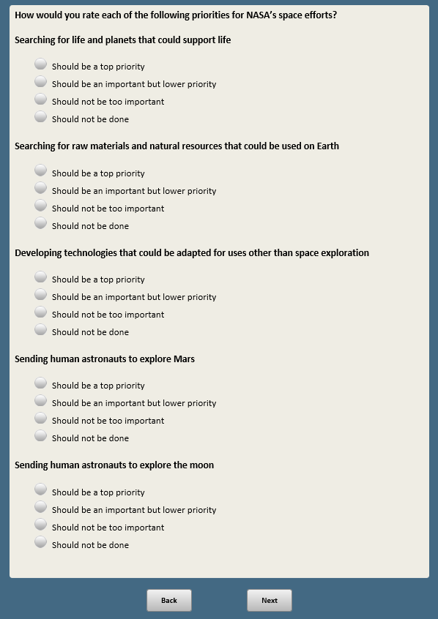 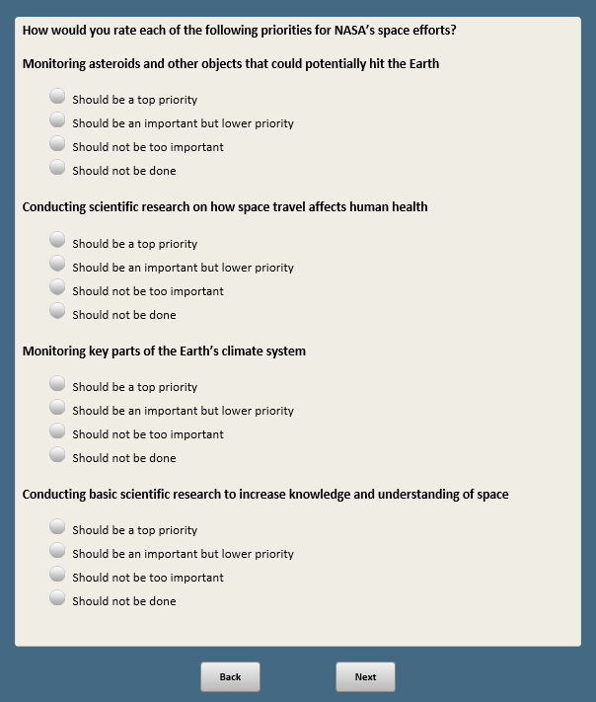

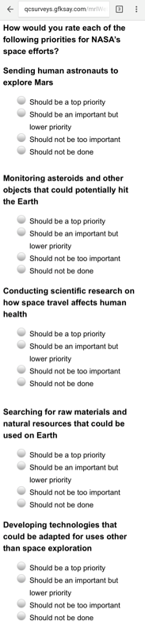 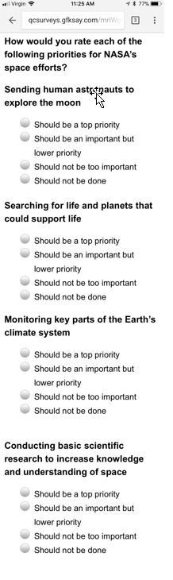

Base: ASK ALL

**SPACE4 [S]**

Do you think the space station has been…

1. A good investment for this country
2. NOT a good investment for this country



Base: ASK ALL

**SPACE5 [S]**

The cost of sending human astronauts to space is considerably greater than the cost of using robotics for space exploration.

As you think about the future of the U.S. space program, do you think it is*…*

1. ESSENTIAL to include the use of human astronauts in space
2. NOT ESSENTIAL to include the use of human astronauts in space

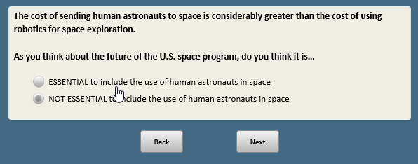

Base: ASK ALL

**SPACE6 [S]**

In your view, do you think it is…

1. ESSENTIAL that the United States continue to be a world leader in space exploration
2. NOT ESSENTIAL that the United States continue to be a world leader in space exploration

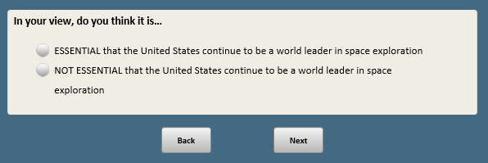

*Note: NO SPACE7 AND SPACE8*

Base: ASK ALL

**SPACE9 [S]**

How much, if anything, have you heard or read about private companies, such as SpaceX, Blue Origin and Virgin Galactic, developing spaceexploration capabilities?

1. A lot
2. A little
3. Nothing at all

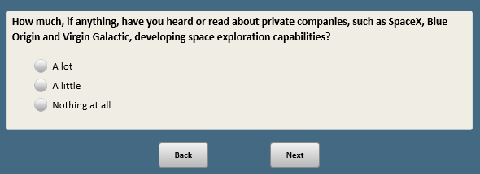

Base: ASK ALL

*Scripter: Randomize and record response order*

**SPACE10 [S]**

Which statement comes closer to your views — even if neither is exactly right?

1. It is essential that NASA continue to be involved in space exploration
2. Private companies will ensure that enough progress is made in space exploration, even without NASA’s involvement

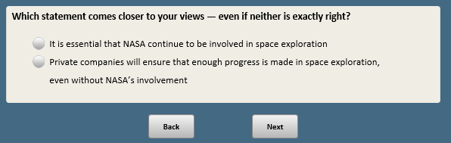

Base: ASK ALL

**SPACE11 [S]**

In the future, private companies expect to allow people to orbit the Earth in a spacecraft. How much, if at all, would you, personally, be interested in doing this?

1. Definitely interested
2. Probably interested
3. Probably NOT interested
4. Definitely NOT interested

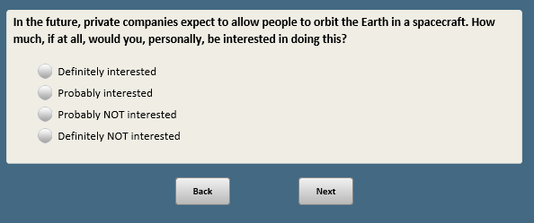

Base: SPACE11=1 or 2 (ASK IF DEFINITELY OR PROBABLY INTERESTED IN ORBITING EARTH IN A SPACECRAFT)

*Scripter: Randomize and record response order. Always keep option 4 last.*

*Sripter: Add custom prompt if 4 (Something else) selected and no text is included in the box:* You did not provide a response in the text box. If you would like to skip, click Next.

**SPACE12 [S]**

What is the MAIN REASON you would be interested in orbiting the Earth in a spacecraft?

1. To see the view of Earth from space
2. To learn more about the world
3. To experience something unique

**[SPACE]**

1. Something else **[O]**

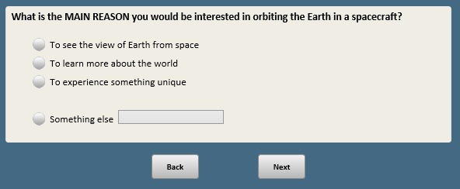

Base: SPACE11=3 or 4 (ASK IF PROBABLY NOT OR DEFINITELY NOT INTERESTED IN ORBITING EARTH IN A SPACECRAFT)

*Scripter: Randomize and record response order. Always keep option 4 last.*

*Sripter: Add custom prompt if 4 (Something else) selected and no text is included in the box:* You did not provide a response in the text box. If you would like to skip, click Next.

**SPACE13 [S]**

What is the MAIN REASON you would NOT be interested in orbiting the Earth in a spacecraft?

1. It would be too expensive
2. It would be too scary
3. My age or health would not allow this

**[SPACE]**

1. Something else **[O]**

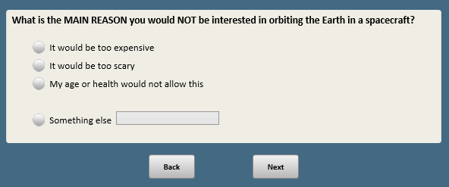

Base: ASK ALL

*Scripter: Randomize and record order of items a-e. Show on same screen.*

**SPACE14 [S]**

How much confidence, if any, do you have that private companies developing space exploration capabilities will…

1. Build rockets and spacecraft that are safe and reliable
2. A great deal of confidence
3. A fair amount of confidence
4. Not too much confidence
5. No confidence at all
6. Minimize the debris from rockets, satellites and other human-made objects in the Earth’s orbit
7. A great deal of confidence
8. A fair amount of confidence
9. Not too much confidence
10. No confidence at all
11. Control costs for developing rockets and spacecraft
12. A great deal of confidence
13. A fair amount of confidence
14. Not too much confidence
15. No confidence at all
16. Conduct basic scientific research to increase knowledge and understanding of space
17. A great deal of confidence
18. A fair amount of confidence
19. Not too much confidence
20. No confidence at all
21. Make a profit for their companies
22. A great deal of confidence
23. A fair amount of confidence
24. Not too much confidence
25. No confidence at all

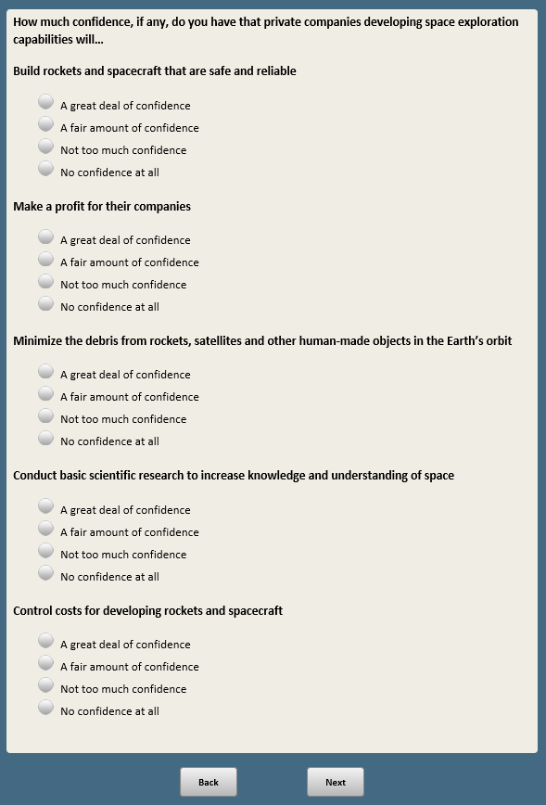 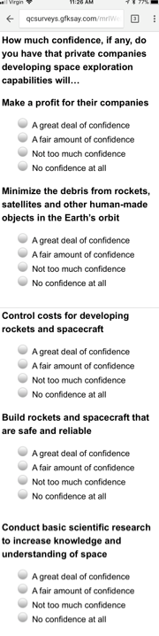

Base: ASK ALL

*Scripter: Randomize and record order of items d-f. Show on same screen.*

**LOCAL [S]**

On another topic…

How much, if at all, is each of the following a problem in your local community?

d. Air pollution

1 Big problem in my local community

2 Small problem in my local community

3 Not a problem in my local community

e. Water pollution of lakes, rivers and streams

1 Big problem in my local community

2 Small problem in my local community

3 Not a problem in my local community

f. Too much land development

1 Big problem in my local community

2 Small problem in my local community

3 Not a problem in my local community

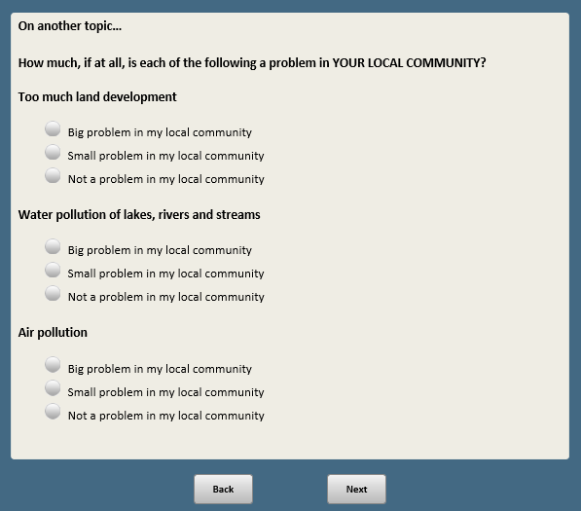 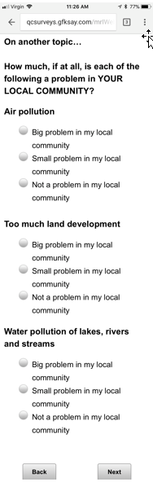

Base: ASK ALL

**ENV1 [S]**

Compared with twenty years ago, do you think the U.S. is producing…

1. More energy today
2. Less energy today
3. About the same amount of energy today

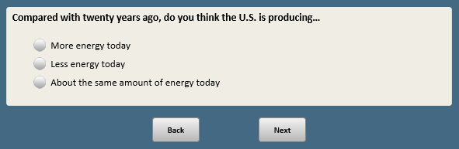

Base: ASK ALL

*Scripter: Randomize and record order of items a-f. Show on same screen.*

**ENV2 [S]**

Do you favor or oppose EXPANDING each of the following sources of energy in our country?

1. More offshore oil and gas drilling in U.S. waters
2. Favor
3. Oppose
4. More nuclear power plants to generate electricity
5. Favor
6. Oppose
7. More coal mining
8. Favor
9. Oppose
10. More solar panel “farms”
11. Favor
12. Oppose
13. More hydraulic fracturing, sometimes called “fracking,” for oil and natural gas
14. Favor
15. Oppose
16. More wind turbine “farms”
17. Favor
18. Oppose

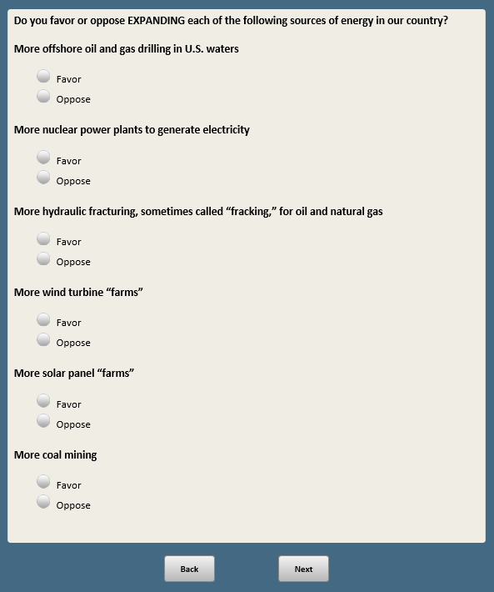 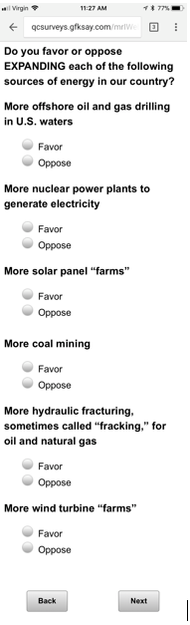

*Note: NO ENVIR3*

Base: ASK ALL

*Scripter: Randomize and record order of items a-e. Show on same screen.*

**ENVIR4 [S]**

How would you rate each of the following priorities for America’s energy policies?

1. Reducing our dependence on foreign energy sources
2. Should be a top priority
3. Should be an important but lower priority
4. Should not be too important
5. Should not be done
6. Creating jobs within the energy sector
7. Should be a top priority
8. Should be an important but lower priority
9. Should not be too important
10. Should not be done
11. Protecting the environment from the effects of energy development and use
12. Should be a top priority
13. Should be an important but lower priority
14. Should not be too important
15. Should not be done
16. Keeping consumer energy prices low
17. Should be a top priority
18. Should be an important but lower but lower priority
19. Should not be too important
20. Should not be done
21. Increasing reliance on renewable energy sources
22. Should be a top priority
23. Should be an important but lower priority
24. Should be not too important
25. Should not be done

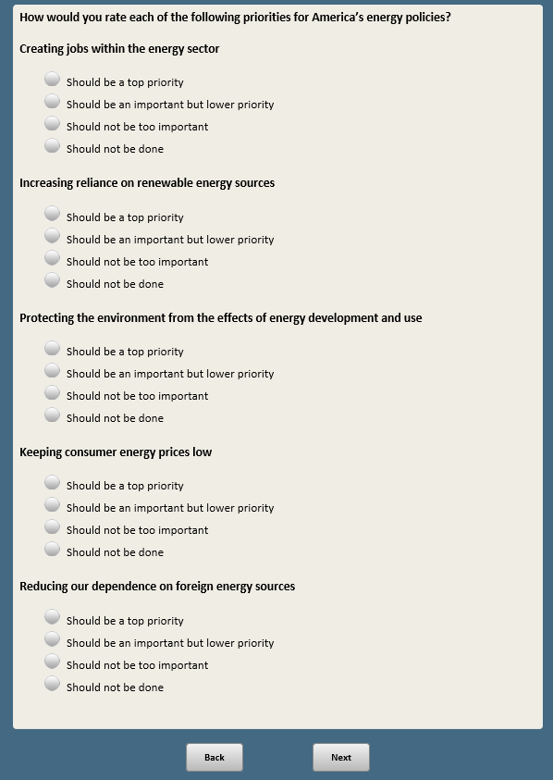 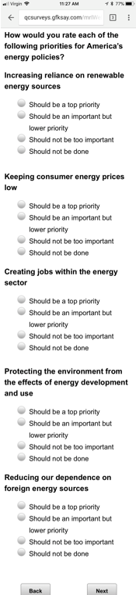

*Note: NO ENVIR5*

Base: ASK ALL

*Scripter: Randomize and record response order.*

**ENVIR6 [S]**

Which of these statements comes closest to your own view about the MOST EFFECTIVE WAY to increase reliance on renewable energy sources, even if neither is exactly right?

1. Government regulations are necessary to encourage businesses and consumers to rely more on renewable energy sources
2. The private marketplace will ensure that businesses and consumers rely more on renewable energy sources, even without government regulations

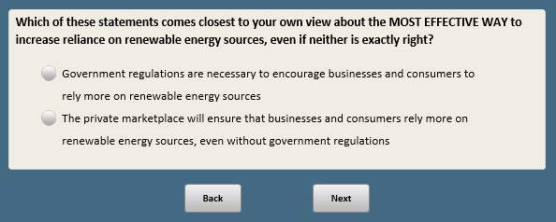

Base: ASK ALL

**ENVIR7 [S]**

Do you think it is possible or not possible to cut back on environmental regulations and still effectively protect air and water quality in the U.S.?

1. Yes, it is possible
2. No, it is NOT possible

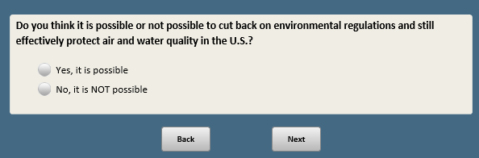

Base: ASK ALL

*Scripter: Randomize and record order of items a-e. Show on same screen.*

**ENVIR8 [S]**

How much do you think the federal government is doing to…

1. Protect air quality
2. Too much
3. Too little
4. About the right amount
5. Protect water quality of lakes, rivers and streams
6. Too much
7. Too little
8. About the right amount
9. Protect animals and their habitats
10. Too much
11. Too little
12. About the right amount
13. Protect open lands in national parks and nature preserves
14. Too much
15. Too little
16. About the right amount
17. Reduce the effects of global climate change
18. Too much
19. Too little
20. About the right amount

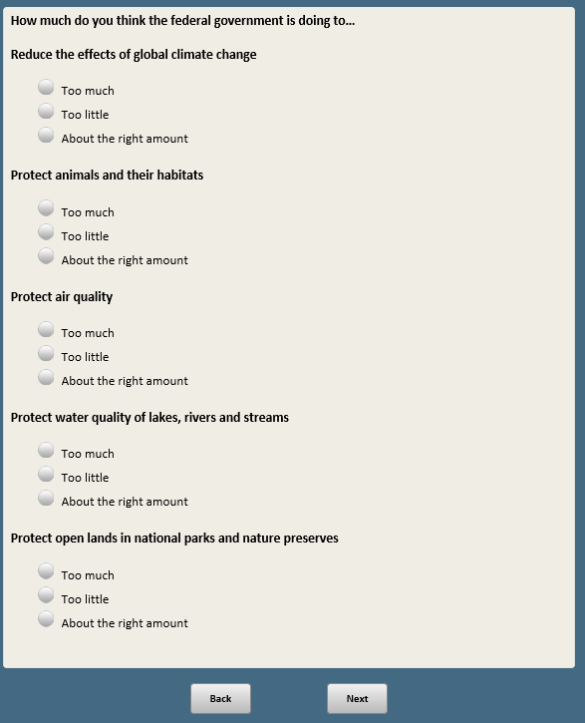 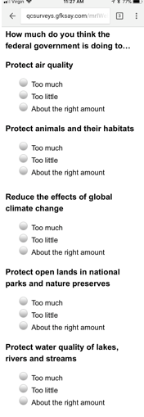

Base: XFORM=1 (FORM 1)

*Scripter: Randomize and record order of response options 1 and 2. Keep 3 and 8 last.*

**CLIM1A [S]**

On the topic of climate change…

Which of these three statements about the Earth’s temperature comes closest to your view?

1. The Earth is getting warmer mostly because of human activity such as burning fossil fuels
2. The Earth is getting warmer mostly because of natural patterns in the Earth’s environment
3. There is no solid evidence that the Earth is getting warmer **[anchor]**

**[SPACE]**

1. Not sure **[anchor]**

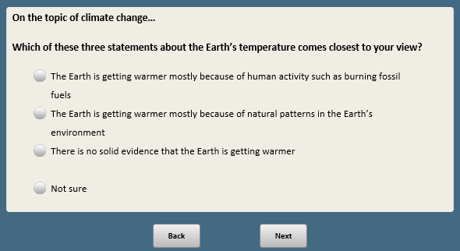

Base: CLIM1A=8 or 99 (ASK IF NOT SURE OR NO ANSWER)

*Scripter: Show in same order as CLIM1A*

**CLIM1B [S]**

Even if you are not sure, which one of these three statements about the Earth’s temperature comes closest to your view?

1. The Earth is getting warmer mostly because of human activity such as burning fossil fuels
2. The Earth is getting warmer mostly because of natural patterns in the Earth’s environment
3. There is no solid evidence that the Earth is getting warmer

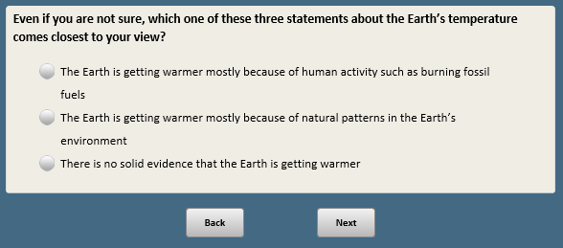

Base: XFORM=2 (ASK FORM 2)

*Scripter: Randomize and record order of response options 1 and 2. Keep 3 and 8 last.*

**CLIM2A [S]**

On the topic of climate change…

From what you have heard or read, which of these three statements about the Earth’s temperature comes closest to WHAT MOST CLIMATE SCIENTISTS SAY?

1. The Earth is getting warmer mostly because of human activity such as burning fossil fuels
2. The Earth is getting warmer mostly because of natural patterns in the Earth’s environment
3. There is no solid evidence that the Earth is getting warmer **[anchor]**

**[SPACE]**

1. Not sure **[anchor]**

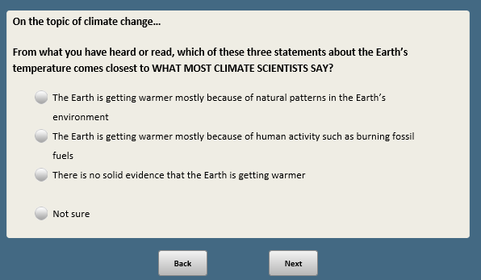

Base: CLIM2A=8 or 99 (ASK IF NOT SURE OR NO ANSWER)

*Scripter: Show in same order as CLIM2A*

**CLIM2B [S]**

Even if you are not sure, which one of these three statements about the Earth’s temperature comes closest to WHAT MOST CLIMATE SCIENTISTS SAY?

1. The Earth is getting warmer mostly because of human activity such as burning fossil fuels
2. The Earth is getting warmer mostly because of natural patterns in the Earth’s environment
3. There is no solid evidence that the Earth is getting warmer

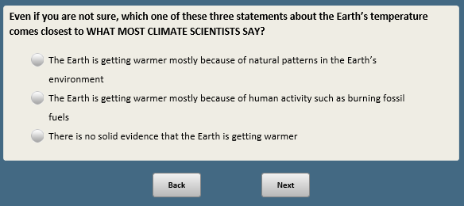

Base: ASK ALL

**CLIM3 [S]**

**[SHOW IF CLIM1A=1,2 OR CLIM1B=1,2 OR XFORM=2:**From what you have heard or read, do you think it is…**]**

**[SHOW IF CLIM1A=3 OR CLIM1B=3,99:** From what you have heard or read, do you think it would be…**]**

1. Possible to reduce the effects of global climate change
2. NOT possible to reduce the effects of global climate change



Base: ASK ALL

**ENV21 [S]**

How much do you, personally, care about the issue of global climate change?

1. A great deal
2. Some
3. Not too much
4. Not at all

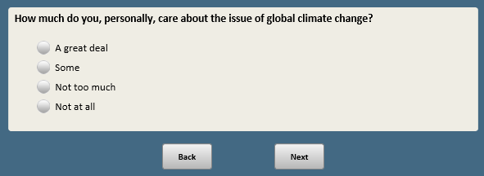

*Note: NO CLIM4*

*Scripter: Randomize and record order of CLIM5 and CLIM6*

Base: ASK ALL

*Scripter: Randomize and record response 1 and 2 order. Show in same order as CLIM6.*

**CLIM5 [S]**

Do you think policies aimed at reducing the effects of global climate change generally…

1. Help the U.S. economy
2. Hurt the U.S. economy
3. Make no difference for the U.S. economy

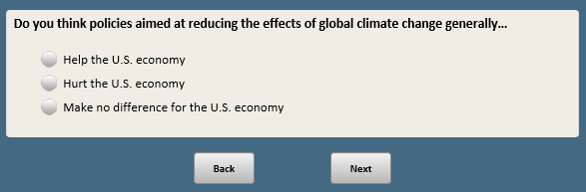

Base: ASK ALL

*Scripter: Randomize and record response 1 and 2 order. Show in same order as CLIM5.*

**CLIM6 [S]**

Do you think policies aimed at reducing the effects of global climate change generally…

1. Do more GOOD than harm for the environment
2. Do more HARM than good for the environment
3. Make no difference for the environment

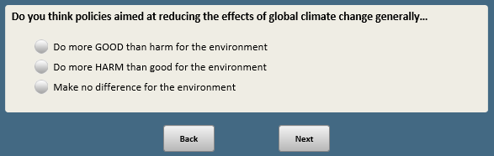

Base: ASK ALL

*Scripter: Randomize and record order of items a-d. Show on same screen.*

**CLIM7 [S]**

Do you think the following would make a difference or not in reducing the effects of global climate change?

1. Restrictions on power plant carbon emissions
2. Make a difference
3. Not make a difference
4. Tougher fuel-efficiency standards for automobiles and trucks
5. Make a difference
6. Not make a difference
7. Tax incentives to encourage businesses to reduce their carbon emissions
8. Make a difference
9. Not make a difference
10. Tax incentives for people to drive hybrid and electric automobiles
11. Make a difference
12. Not make a difference

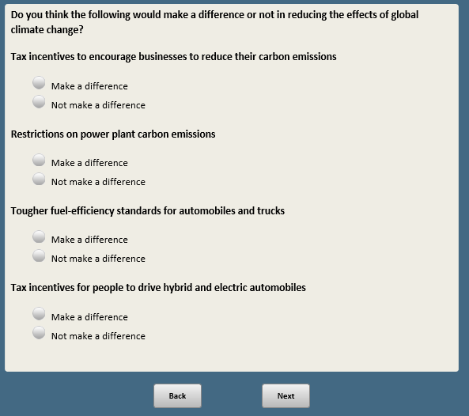 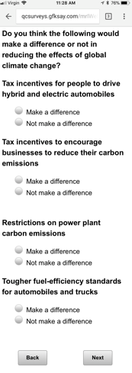

Base: If multiple selections at CLIM7a-d=1

*Scripter: Show only items selected 1 (Make a difference) at CLIM7a-d. Show in same order.*

*Scripter: IF only one item selected 1 (Make a difference) at CLIM7a-d, autopunch here and do not show to respondent.*

**CLIM7BIG [S]**

Which ONE of the following proposals do you think would make the BIGGEST DIFFERENCE in reducing the effects of global climate change?

1. Restrictions on power plant carbon emissions
2. Tougher fuel-efficiency standards for automobiles and trucks
3. Tax incentives to encourage businesses to reduce their carbon emissions
4. Tax incentives for people to drive hybrid and electric automobiles

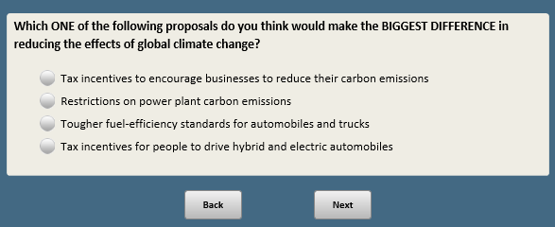

Base: ASK ALL

*Scripter: Randomize and record order of responses 1 and 2 for CLIM8b. Do not randomize CLIM8a responses.*

**CLIM8 [S]**

One proposal to reduce the effects of global climate change would use solar geoengineering techniques — for example, spreading particles in the atmosphere to reflect sunlight and thereby lower the Earth’s temperature.

a. Do you think using these techniques would…

1. Make a difference in reducing the effects of global climate change
2. Not make a difference in reducing the effects of global climate change
3. Beyond the potential of these solar geoengineering techniques to reduce the effects of global climate change, overall, do you think using these techniques would…
4. Do more GOOD than harm for the environment
5. Do more HARM than good for the environment
6. Make no difference for the environment

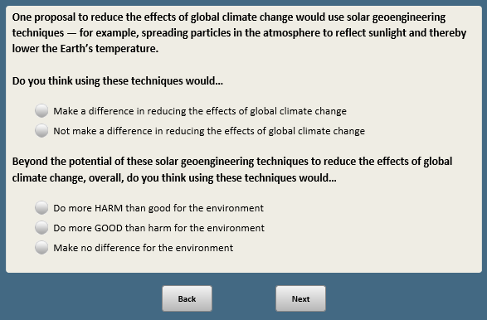

Base: ASK ALL

**CLIM9 [S]**

How much, if at all, do you think global climate change is currently affecting…

1. The United States
2. A great deal
3. Some
4. Not too much
5. Not at all
6. Your local community
7. A great deal
8. Some
9. Not too much
10. Not at all

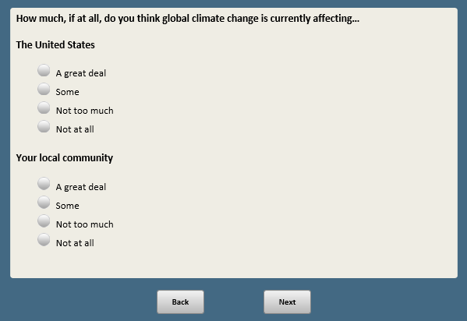

Base: CLIM9b=1 or 2 (ASK IF LOCAL COMMUNITY AFFECTED A GREAT DEAL OR SOME)

*Scripter: Allow as many characters as possible*

**CLIM10 [O]**

What is the MAIN way that global climate change is currently affecting your local community?

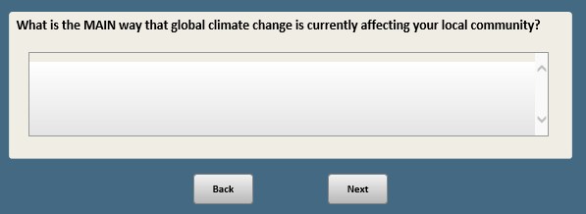

Base: CLIM9b=1 or 2 (ASK IF LOCAL COMMUNITY AFFECTED A GREAT DEAL OR SOME)

**CLIM11 [S]**

Would you say the effects of global climate change in your local community are impacting you, personally, or not?

1. Yes, the effects are impacting me personally
2. No, the effects are NOT impacting me personally

~~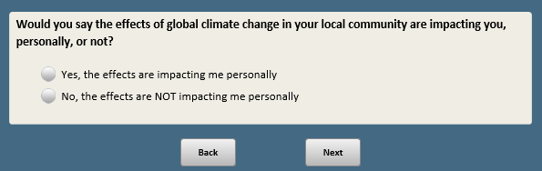~~

Base: ASK ALL

*Scripter: Randomize and record order of items a-e. Show on same screen.*

**PREVSHOOT [S]**

On a different topic…

How effective, if at all, do you think each of the following would be at preventing school shootings?

a. Preventing people with mental illnesses from purchasing guns

1 Very effective

2 Somewhat effective

3 Not too effective

4 Not at all effective

b. Banning assault-style weapons

1 Very effective

2 Somewhat effective

3 Not too effective

4 Not at all effective

c. Allowing teachers and school officials to carry guns in schools

1 Very effective

2 Somewhat effective

3 Not too effective

4 Not at all effective

d. Improving mental health screening and treatment

1 Very effective

2 Somewhat effective

3 Not too effective

4 Not at all effective

e. Having metal detectors in schools

1 Very effective

2 Somewhat effective

3 Not too effective

4 Not at all effective

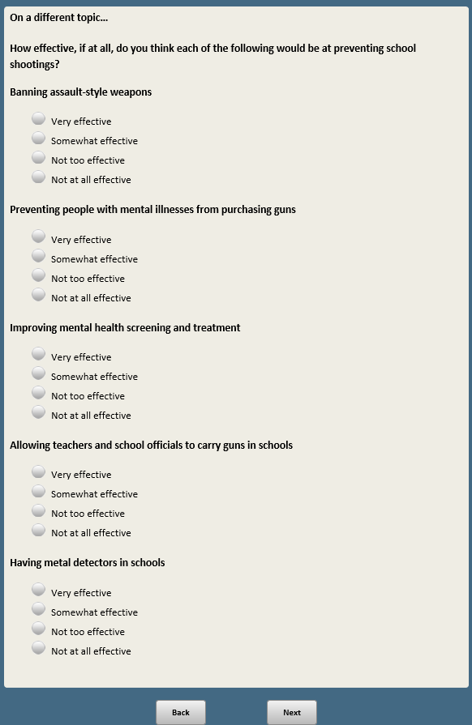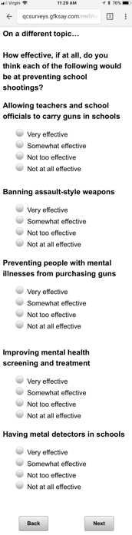

1. Open-end responses are excluded from public datasets to protect the confidentiality of ATP panelists